

SIMATS ENGINEERING

Saveetha Institute of Medical and Technical Sciences
Chennai- 602105

Student Name: G.Pradeep ranga reddy Reg. No.:192311289
Course Code: CSA4305 Slot: D
Course Name: INTERNET PROGRAM
Course Faculty: Dr.D.Sudhagar
Project Title: Smart healthcare resource allocation and appointment scheduling system
Module Photographs: (3 photographs –Module Photo, Individual student contribution module work in the project and presentation image)
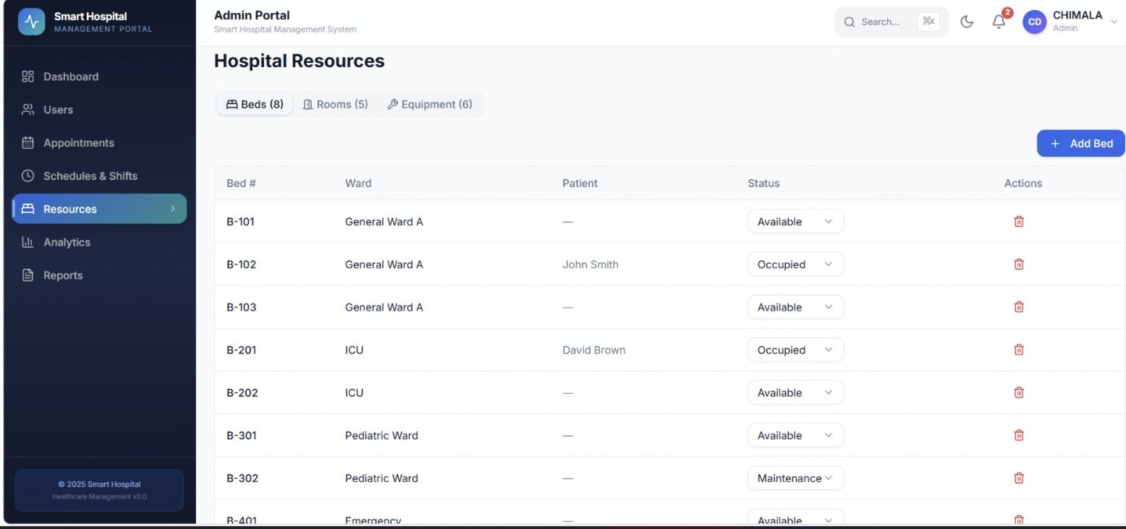
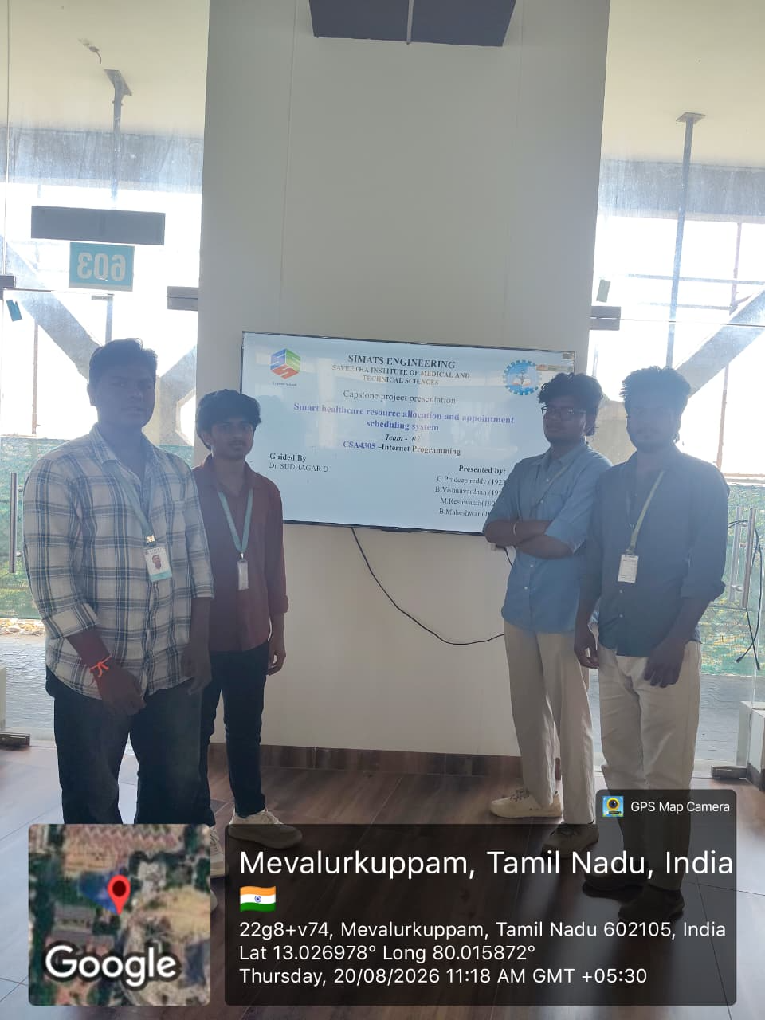
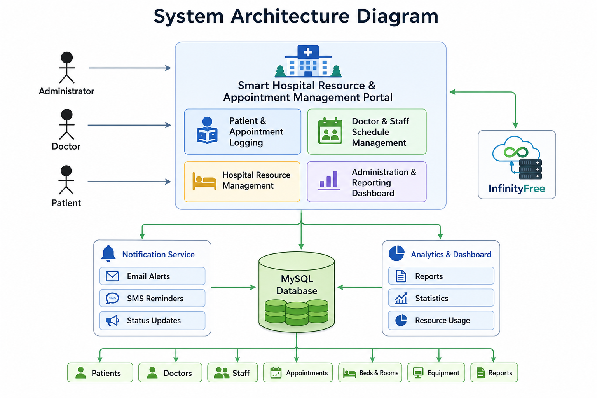
Project Description: Hospital Resource Management
The Hospital Resource Management project is designed to manage and organize hospital resources efficiently.
It helps maintain records of medical equipment, medicines, hospital rooms, and other essential resources.
The system allows administrators to add, update, and remove resource details easily.
It keeps track of the availability and usage of hospital equipment.
Medicine stock can be monitored to avoid shortages and unnecessary wastage.
The system helps manage hospital rooms, beds, and their availability.
It provides quick information about resources whenever they are required.
Proper resource allocation can be done based on the needs of different departments.
It helps reduce manual paperwork and improves record management.
The system can provide alerts when medicines or important supplies are running low.
It improves the utilization of available hospital resources.
Administrators can monitor resource usage and maintain accurate records.

Student Signature Guide Signature

